CFI-A,
Commercial,
Maneuvers
Guide

10-01-2019

R. Coulson
10-01-2019
Normal Takeoff & Climb AFH 5-3
Flaps = 10º
Check approach for traffic
Taxi onto runway, lineup with centerline
Use proper control inputs for wind conditions
Verify runway # with heading indicator
Smooth and continuous application of full throttle
Callout: Instruments in the green
Airspeed alive
Rotate
Rotate at 55 kts
Attitude – 7º nose up
Climb at Vy – 74kts
Flaps up > 60 kts, > 200’ (safe altitude)
500’ – climb power, climb at 80 kts

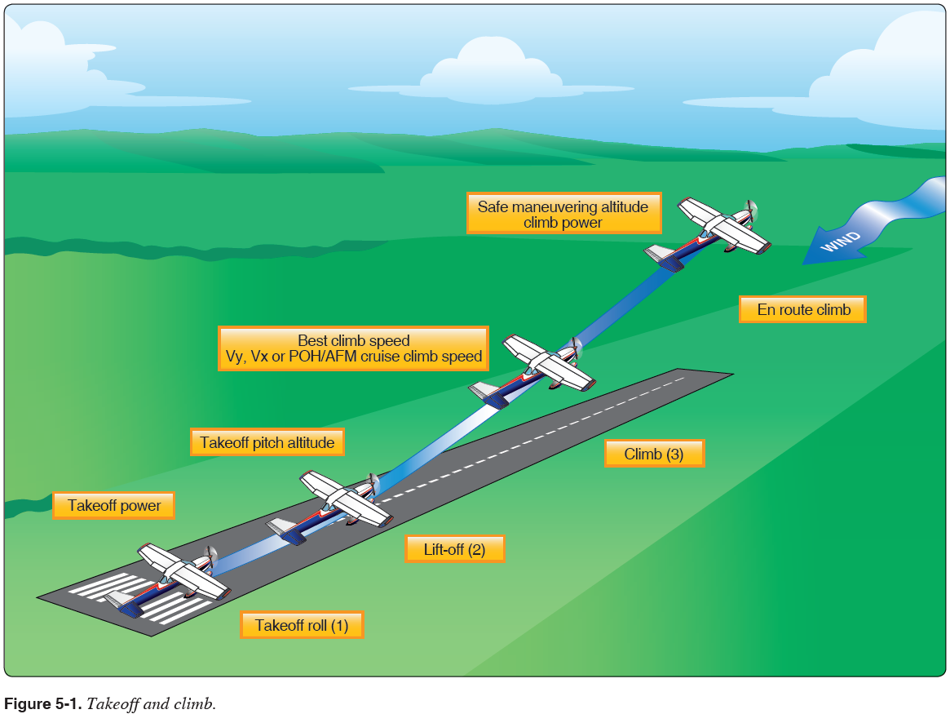

Cross Wind Takeoff & Climb AFH 5-6

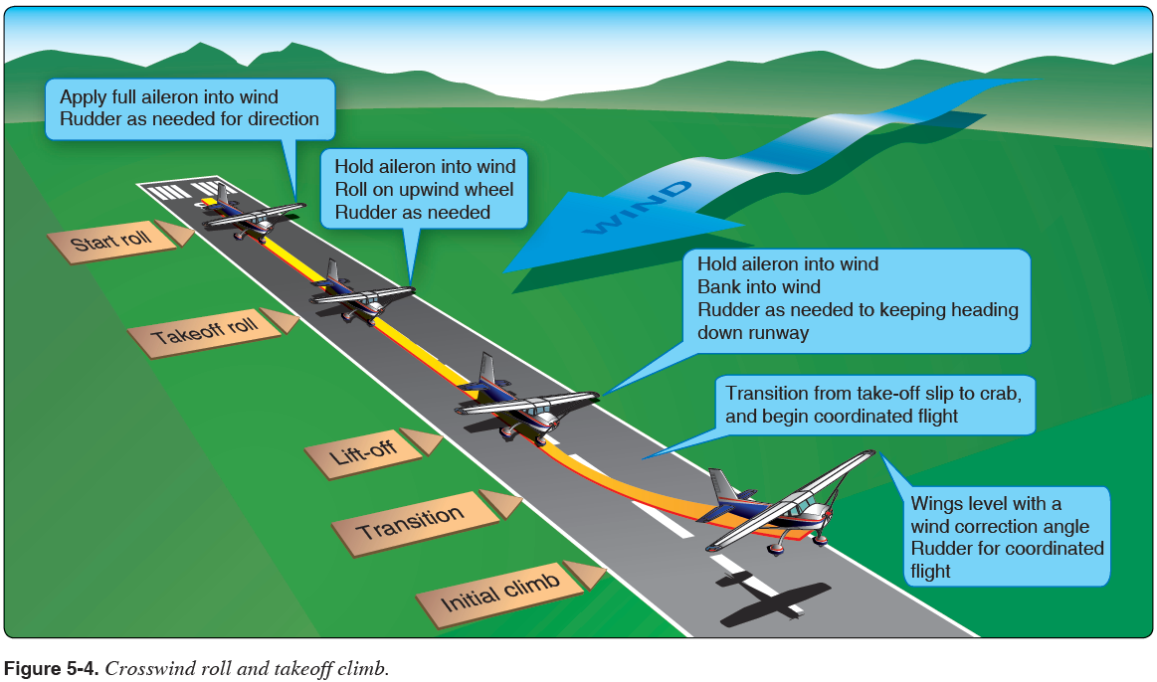
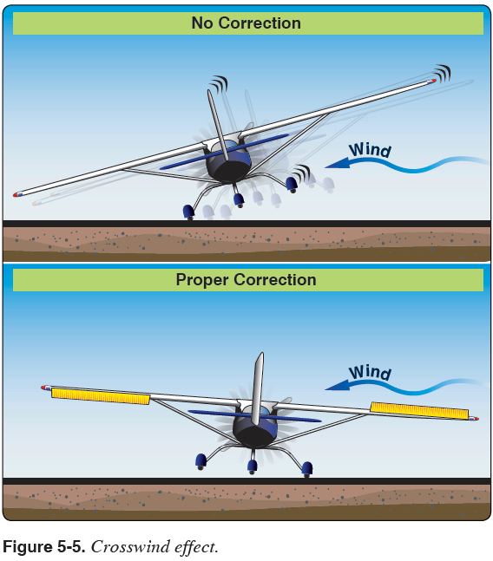
Short Field Takeoff & Max Performance Climb AFH 8-11
Confirm runway length required to T/O and clear 50’ obstacle
Flaps = 10º
Check approach for traffic
Taxi onto runway, lineup on centerline at edge of threshold
Use proper control inputs for wind conditions
Verify runway # with heading indicator
Hold brakes
Smooth application of full throttle. Callout: Instruments in the green
Release brakes and accelerate
Callout: Airspeed alive
Rotate
Rotate at 55 kts
Climb at Vx - 62 kts until clear obstacle (POH specifies 56 kts)
Climb at Vy – 74kts
Flaps up > 60 kts, > 200’ (safe altitude)
500’ – climb power, climb at 80 kts

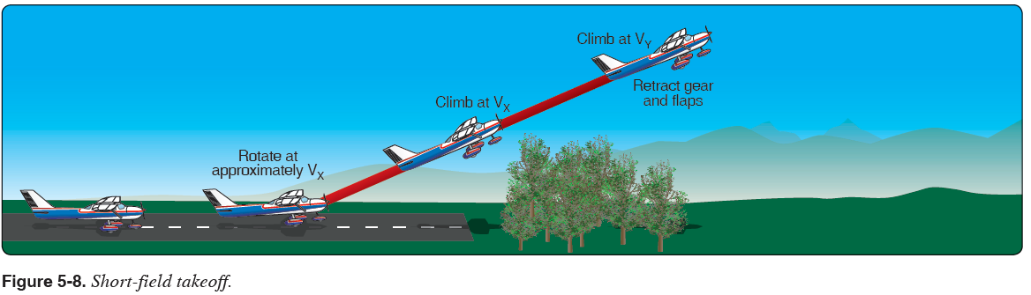

Common Errors
- Improper runway incursion avoidance procedures
- Improper use of controls during a short field takeoff
- Improper lift off procedures
- Improper initial climb attitude, power setting, and airspeed (Vx), to clear obstacle
- Improper use of checklist

Short Field T/O distance Gross Weight
C-172S, 100º F (38º C), Sea level 2,400 lbs 2,500 lbs
Ground roll: 980’ 1,140’
T/O over 50’ obstacle: 1,665’ 1,930’
Soft Field Takeoff & Climb AFH 5-11
Technique for getting the airplane airborne as quickly as possible to eliminate drag from field elements.
Uses judicious use of ground effects to accomplish this task.

Flaps = 10º
Check approach for traffic
Maintain full AFT stick position for taxi and initial takeoff roll
Taxi onto runway, lineup with centerline (do not stop, keep AC moving)
Use proper control inputs for wind conditions
Verify runway # with heading indicator
Smooth and continuous application of full throttle
Callout: Instruments in the green
Airspeed alive
Allow AC to accelerate in nose high attitude, less pressure as aircraft accelerates to maintain attitude
Aircraft will lift off into ground effect
Lower angle of attack to accelerate in ground effect
Accelerate to 56 kts for obstacle or Vy if no obstacle
(Climb at 56 kts until clear of obstacle then at Vx)
Clear of obstacle or 200’ flaps up
Climb at Vy – 74kts
500’ – climb power, climb at 80 kts

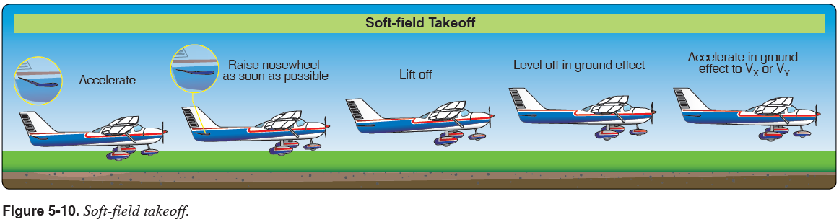

Common Errors
- Improper runway incursion avoidance procedures
- Improper use of controls during a soft-field takeoff
- Improper lift off procedures
- Improper climb attitude, power setting, and airspeed (Vy or Vx)
- Improper use of checklist

Normal & Crosswind Approach & Landing AFH 8-2, 8-14
5 Phases:
- Downwind 90 kts, reduce to 1700 rpm, flaps 10º, trim for 85 kts
- Base Leg flaps 20º, 75 kts
- Final Approach flaps 30º, 65 kts
- Round Out
- Touchdown
- After landing roll

Objective: To develop the student’s ability to safely and accurately land the airplane in a designated area.
Procedure:
- Fly the traffic pattern following the Traffic Pattern Operations procedure as above
- On the Final leg:
- Set the flaps to 30°.
- Adjust pitch and power to maintain the descent to touchdown point at 65 KIAS.
  - Add 1/2 gust factor as necessary.
- Once landing is assured, reduce power to idle and continue the flare to touchdown on the main tires within 200’ beyond a specified point.
- Hold the nose gear off of the runway with back-pressure.
- After the nose wheel has touched the ground, gently apply brakes while maintaining runway centerline.

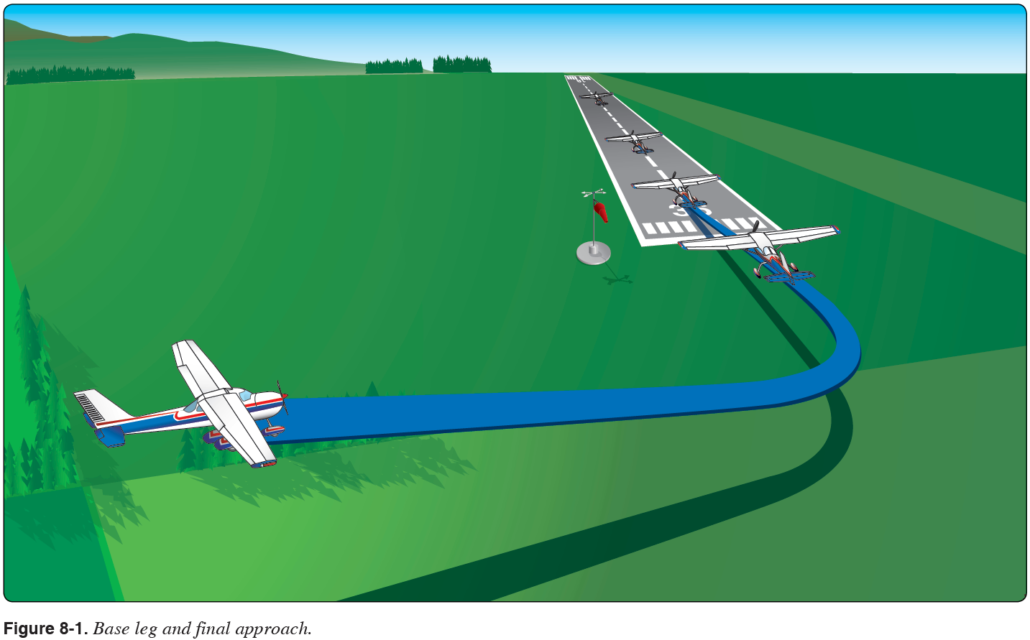
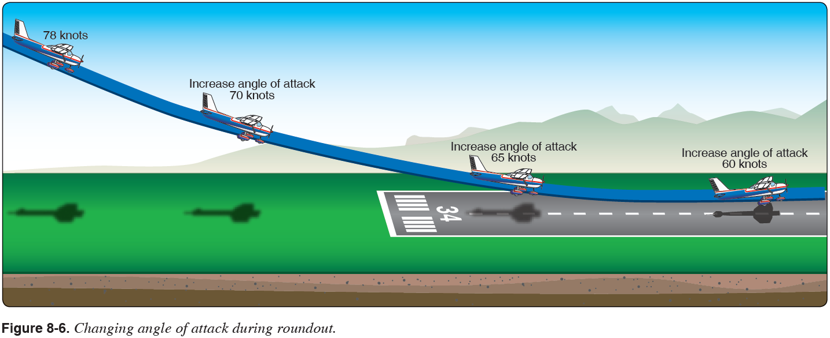

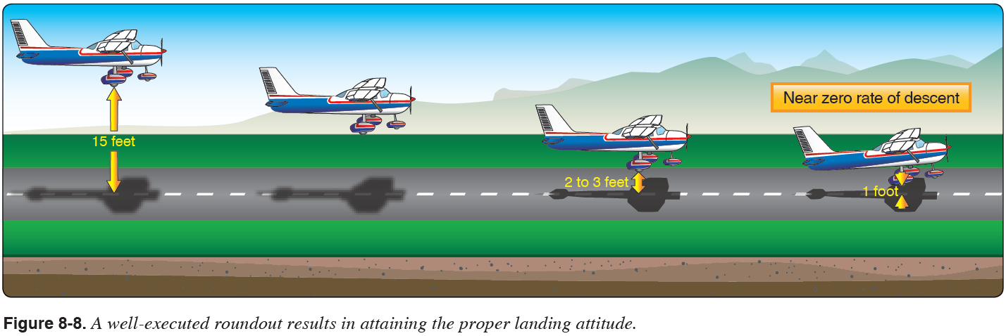
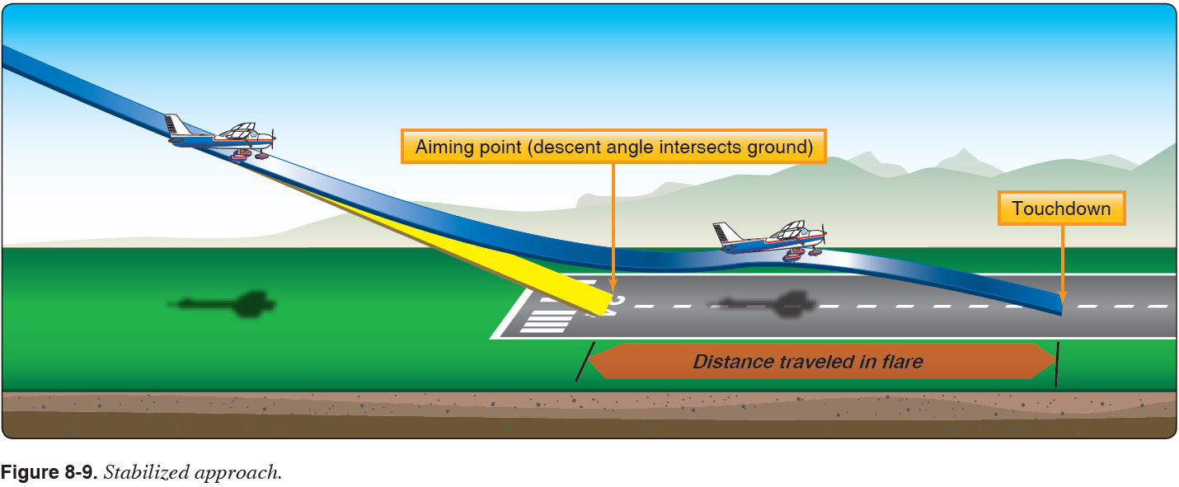
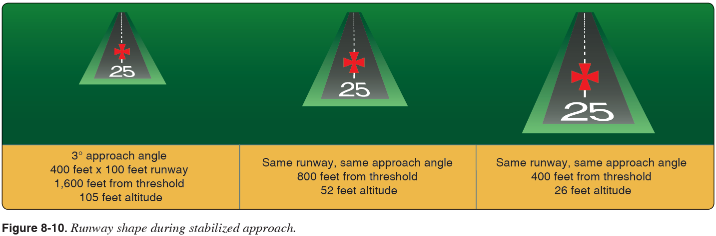
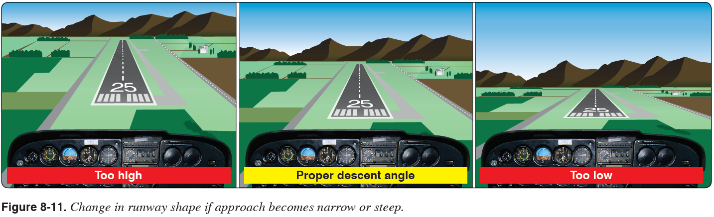

Approach path with 3º Glide Slope
Distance (SM) | 0.075 | 0.25 | 0.5 | 0.75 | 1 | 1.25 | 1.5
Feet | 396 | 1320 | 2640 | 3960 | 5280 | 6600 | 7920
Altitude (ft) | 56 | 188 | 376 | 564 | 753 | 941 | 1129

Crosswind Approach & Landing AFH 8-14

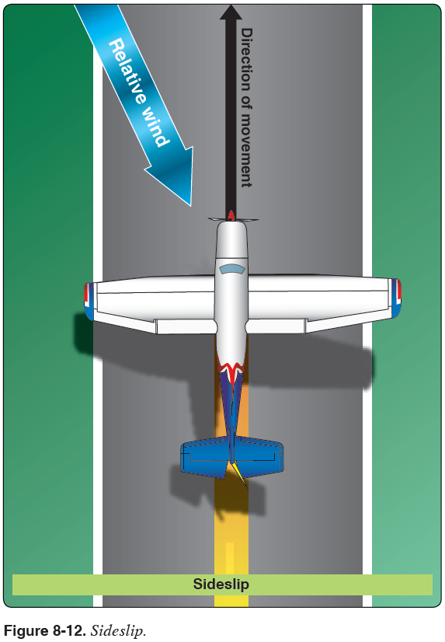
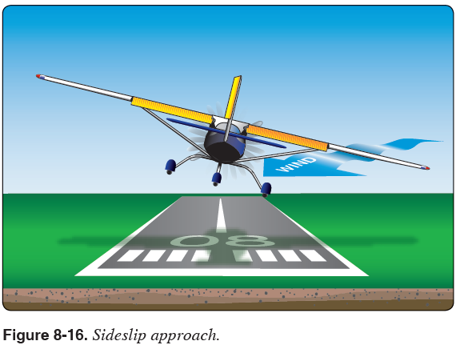
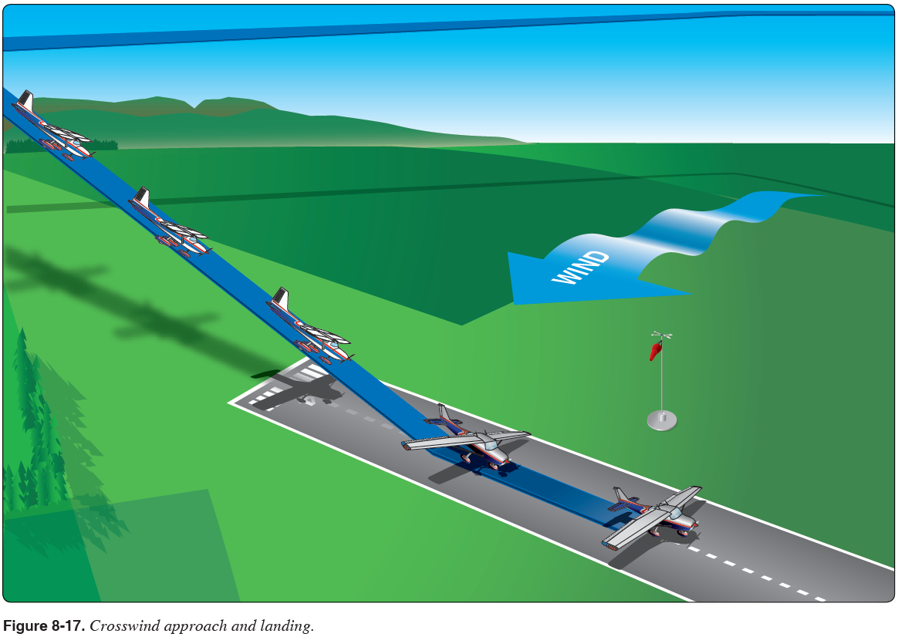

Common Errors
- Improper use of landing performance data and limitations
- Failure to establish approach and landing configuration at appropriate time or in proper sequence
- Failure to establish and maintain a stabilized approach
- Inappropriate removal of hand from throttle
- Improper procedure during round-out and touchdown
- Poor directional control after touchdown
- Improper use of brakes
- Failure to ensure receipt and acknowledgement of landing clearance
- Failure to review airport diagram for runway exit situational awareness to avoid a runway incursion after landing

Forward Slip to Landing AFH 8-11

Objective: To develop the student’s ability to dissipate altitude without increasing the airplane’s speed during a forward slip to landing.
Procedure:
- Fly the traffic pattern following the Traffic Pattern Operations as in the normal approach.
- Do not descend below 500’ AGL until the Final leg.
- On the Final leg:
- Reduce the throttle to idle.
- Note the wind direction.
- Smoothly apply full rudder in the opposite direction of the wind.
- Use opposite aileron to slip into the wind.
- Fly at an airspeed of 65 KIAS.
  - Add 1/2 gust factor as necessary.
- At the round out, align the airplane with the runway centerline by releasing rudder pressure and adjust the ailerons as necessary to keep the wings level.
- Flare to touch down on the main wheels first within 400’ beyond a specified point.
- After the nose wheel is down, gently apply brakes.
Note: Because of the location of the pitot tube and static port, the airspeed indicator may have a considerable degree of error.
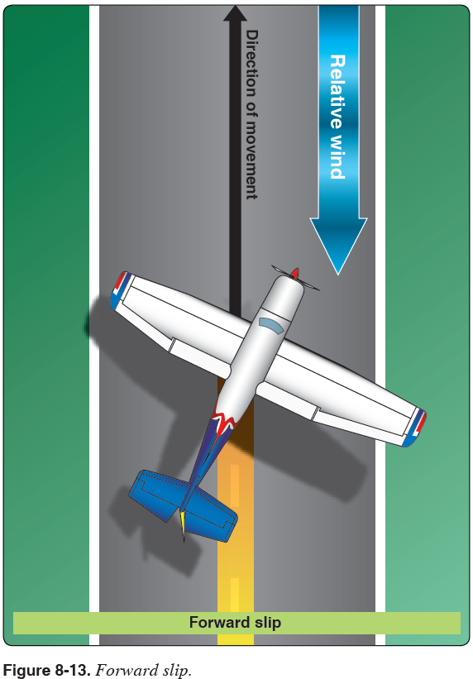

Common Errors
- Improper use of landing performance data and limitations
- Failure to establish approach and landing configuration at appropriate time or in proper sequence
- Failure to maintain a stabilized slip
- Inappropriate removal of hand from throttle
- Improper procedure during transition from the slip to the touchdown
- Poor directional control after touchdown
- Improper use of brakes
Go-Around / Rejected Landing AFH 8-12 10-01-2019

Objective: To develop the student’s ability to discontinue the approach and attempt another approach under more favorable conditions.
Procedure:
- Make decision to go-around
- Apply max power, adjust pitch for level flight
- Flaps to 20º
- Increase airspeed to 60 kts
- Climb at 62 kts,, flaps 10º
- Obstacles cleared & 65 kts, flaps up
- Pitch up to 7º for Vy – 74 kt climb

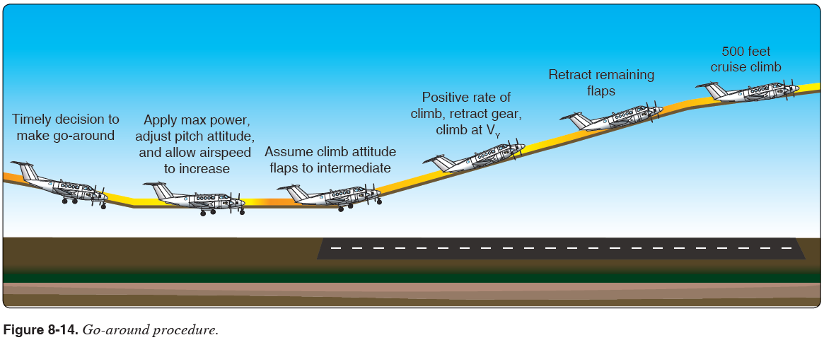

Common Errors
- Failure to recognize a situation where a go-around/rejected landing is necessary
- Hazards of delaying a decision to go around/reject the landing
- Improper power application
- Failure to control pitch attitude
- Failure to compensate for torque effect
- Improper trim procedure
- Failure to maintain recommended airspeeds
- Improper wing flaps or landing gear retraction procedure
- Failure to maintain proper track during climb-out
- Failure to remain well clear of obstructions and other traffic

Short Field Approach & Landing AFH 8-18 10-01-2019

Objective: To develop the student’s ability to obtain maximum performance from the aircraft so that the landing may be consistently accomplished with precision in a short distance.

Because the final approach over obstacles is made at a relatively steep approach angle and close to the airplane’s stalling speed, the initiation of the round out or flare must be judged accurately to avoid flying into the ground or stalling prematurely and sinking rapidly. A lack of floating during the flare with sufficient control to touch down properly is verification that the approach speed was correct.

Procedure:
- Fly the traffic pattern following the Traffic Pattern Operations procedure as in normal approach.
- On the Final leg:
- Set the flaps to 30°.
- Adjust pitch and power to maintain the descent to touchdown point at 61 KIAS.
  - Add 1/2 gust factor as necessary.
- Maintain the predetermined aiming point with pitch and power corrections until approaching the round out. – (Steeper stabilized approach over 50’ obstacle)
- Once landing is assured, reduce power to idle and continue the flare to touchdown at the predetermined point or beyond within 100’ on the main tires first.
- In a controlled and deliberate manner, lower the nose gear to the runway.
- After the nose wheel has touched the ground, apply full back pressure with the yoke.
- Retract the flaps to zero and smoothly apply maximum braking without locking up the wheels while maintaining the aircraft on the runway centerline.
Note: This maneuver is NOT complete until the aircraft has come to a COMPLETE stop.
Note: Approach speed should be increased as required (typically 5 to 15 KIAS) if turbulence or wind shear conditions exist.

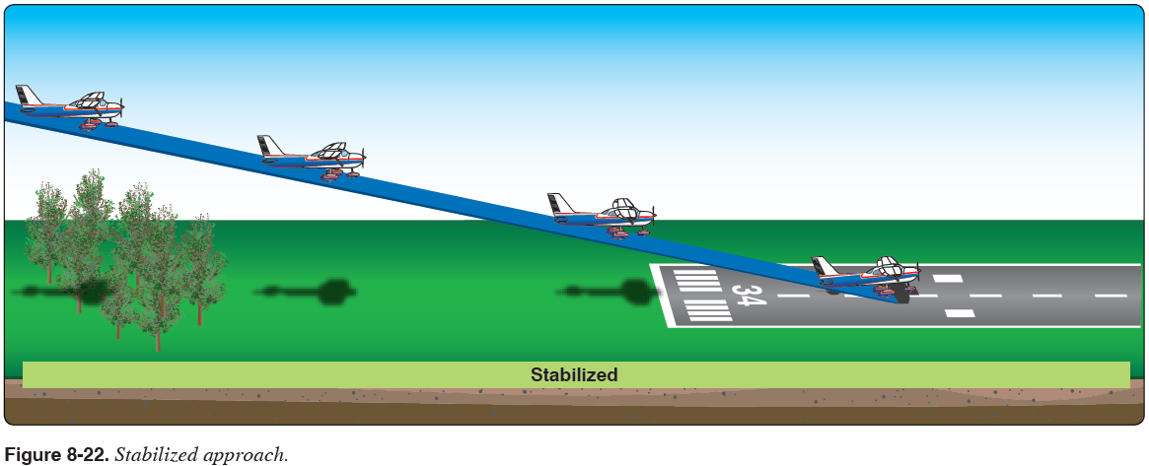
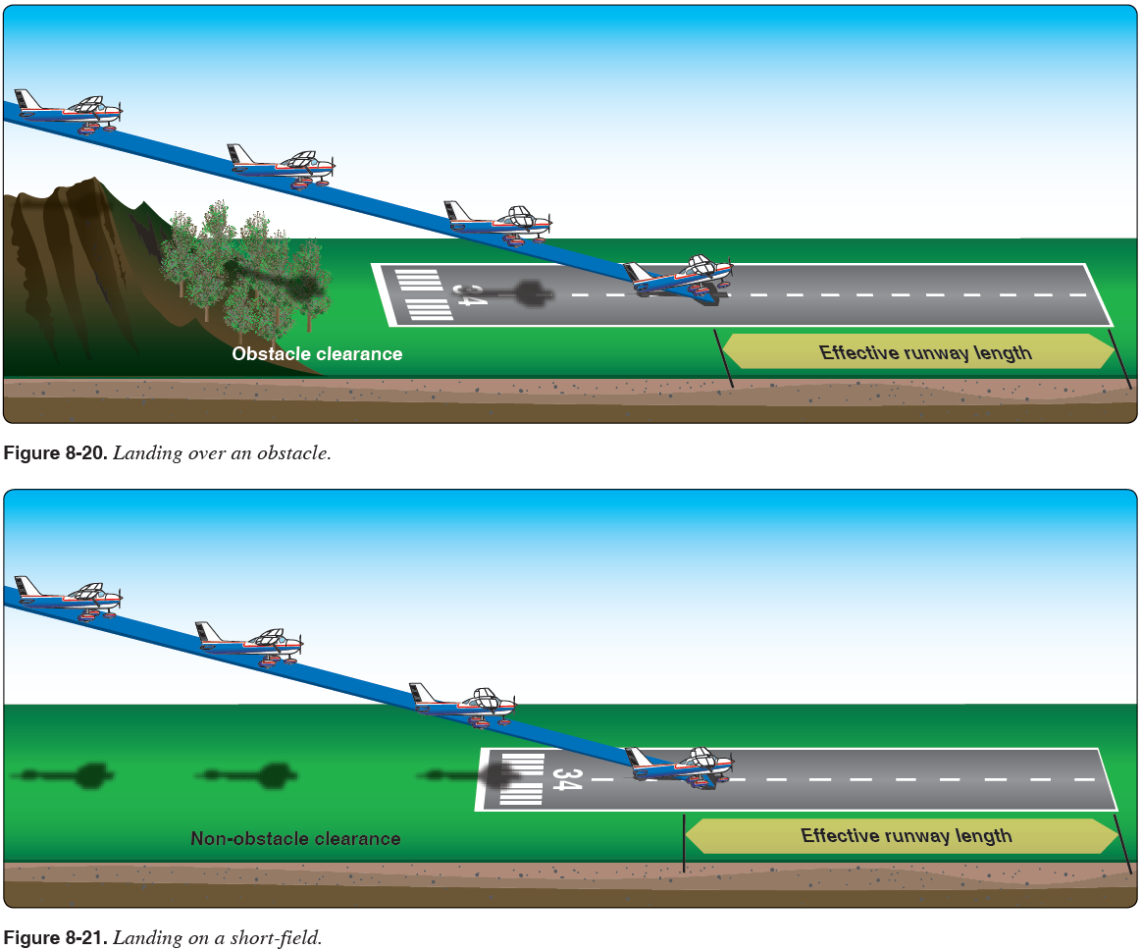

Common Errors
- Improper use of landing performance data and limitations
- Failure to establish approach and landing configuration at appropriate time or in proper sequence
- Failure to establish and maintain a stabilized approach
- Improper procedure in use of power, wing flaps, and trim
- Inappropriate removal of hand from throttle
- Improper procedure during round-out and touchdown
- Poor directional control after touchdown
- Improper use of brakes

Soft Field Approach & Landing AFH 8-21 10-01-2019

Objective: To develop the student’s ability to obtain maximum performance from the aircraft so that a soft touchdown at the slowest possible airspeed can be accomplished.

Procedure:
- Fly the traffic pattern following the Traffic Pattern Operations procedure as in the normal approach.
- On the Final leg:
- Set the flaps to 30°.
- Adjust pitch and power to maintain the descent to touchdown point at 65 KIAS.
  - Add 1/2 gust factor as necessary.
- During the round out add a slight amount of power to prolong flight in ground effect.
- Slowly reduce power and allow the aircraft to settle onto the runway on the main wheels
- Close the throttle during the roll out while holding the nose off the runway with back pressure
- Flaps should remain extended until clear of the runway.
- After the nose wheel has touched the ground, maintain the runway centerline and DO NOT apply brakes.
- Keep the aircraft moving and maintain elevator back pressure while taxiing on a soft surface.

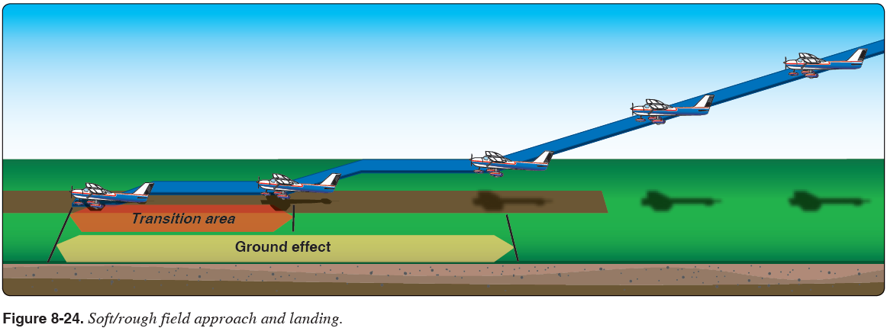

Common Errors
- Improper use of landing performance data and limitations
- Failure to establish approach and landing configuration at appropriate time or in proper sequence
- Failure to establish and maintain a stabilized approach
- Failure to consider the effect of wind and landing surface
- Improper procedure in use of power, wing flaps, and trim
- Inappropriate removal of hand from throttle
- Improper procedure during round-out and touchdown
- Failure to hold back elevator pressure after touchdown
- Closing the throttle too soon after touchdown
- Poor directional control after touchdown
- Improper use of brakes
Power-Off 180º Accuracy Approach & Landing AFH 8-23 10-01-2019

Objective: To teach the student to develop judgement in estimating distances and glide ratios to accurately touchdown on a previously chosen point on the runway.
Procedure:
- Fly the pattern using the Traffic Pattern Operations procedure as in the normal approach.
- When the aircraft is abeam the point of intended landing, reduce the throttle to idle and maintain altitude until reaching best glide speed of 68 kts.
- Use the flaps as necessary to maintain desired descent gradient.
- At the round out, continue the flare to touchdown on the main tires first.
- Touch down within 200’ beyond a specified point.
- In a controlled and deliberate manner, lower the nose gear to the runway.
- Retract the flaps to zero. ?????
- After the nose wheel has touched the ground, gently apply brakes while maintaining runway centerline.

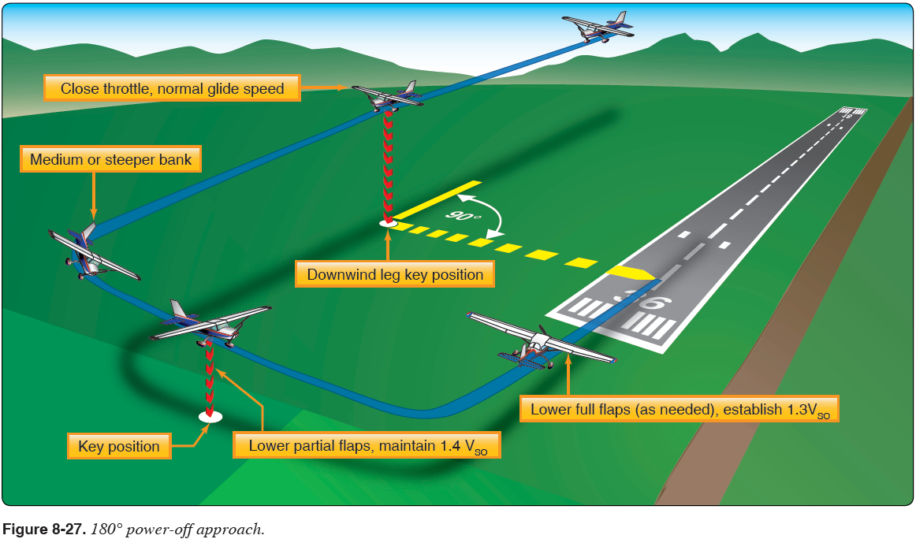

Common Errors
- Failure to establish approach and landing config at proper time or in proper sequence.
- Failure to identify the key points in the pattern
- Failure to establish and maintain a stabilized approach.
- Failure to consider the effect of wind and landing surface.
- Improper use of power, wing flaps, or trim.
- Improper procedure during round out and touchdown.
- Failure to hold back elevator pressure after touchdown
- Poor directional control after touchdown.
- Improper use of brakes.

Emergency Approach & Landing AFH 8-26 10-01-2019
- Emergency Approach and Landing simulates an emergency situation where an aircraft is required to descend as rapidly as possible to a forced landing with little or no power (engine failure) available
- Additionally, Emergency Approach and Landing improve pilot technique for power off turns, wind drift control, planning, orientation, and division of attention

Procedure:
- Clearing Turns (left then right), Call intensions 123.5
- Power to idle. Flaps up. Establish best glide attitude for 68 KIAS
- Trim to maintain airspeed
- Determine the wind direction
- Select a reference point (& landing area) that is near an area where an emergency landing can be made
- Fields are best, roads may contain powerlines
- Look for flat, low populated, low obstruction areas
- Turn the aircraft toward the landing site
- Complete the engine failure during flight checklist:
- If engine restart is unsuccessful, plan and fly a pattern
- Establish a high-key point at 1,000' AGL downwind and abeam to the touchdown point
- Establish a low-key point at 500' AGL on base before the turn to final
- Maneuver as necessary to reach the high-key point
- Not to exceed 60°
- Clear the engine on the upwind legs every turn
- Operating the engine at idle speed for prolonged periods may result in excessive engine cooling or spark plug fouling
- Check engine operation during the glide by "clearing" the engine on every upwind or every 1,000' AGL (to minimize any variation in ground-speed and turn radius) as appropriate

NOTE:
When spiraling, the bank angle can be adjusted to vary altitude loss so as to arrive at the high key point at the appropriate altitude. The Cessna 172S loses approx. 800 -1000' in a 20° bank - 360° turn; and approximately 400 - 500' in a 45° bank - 360° turn. If altitude does not permit the use of a high-key point, proceed to a low key point.

- Turn onto the base leg to be able to conserve or dissipate altitude to reach the desired landing point
- At low-key position, set flaps to 10° if desired
- Turn final to align with the landing site and, when the landing is assured, set the flaps to 30° if desired
- Complete the engine failure – FIELD MADE checklist to secure the engine
- Touchdown slightly tail low and apply brakes as required
- Fly slightly high with options to slip than too low with no options

NOTE:
Unless the approach is made to an airport runway, the simulated emergency approach and landing should be terminated as soon as it can be determined that a safe landing could have been made, or 500' AGL, whichever occurs first.

- Complete the cruise checklist

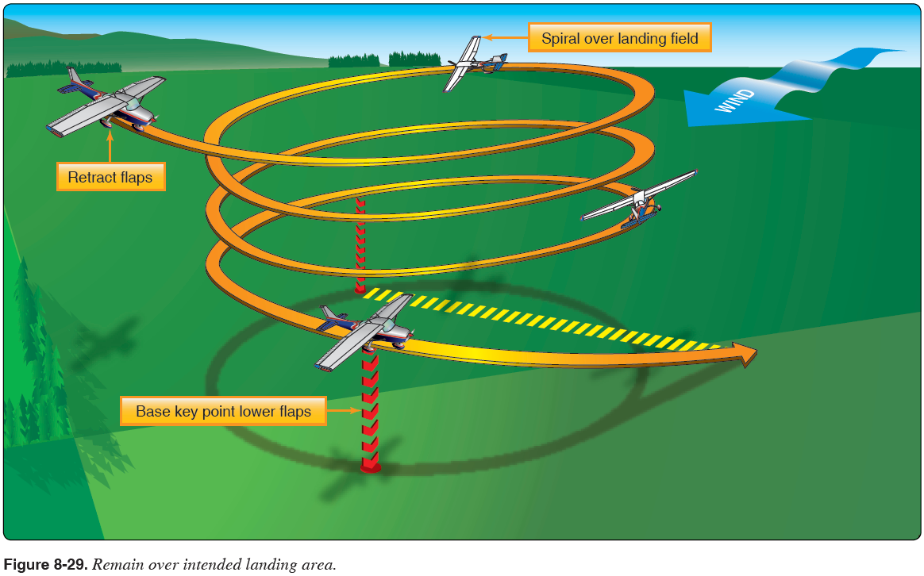

Common Errors:
- Improper airspeed control
- Poor judgement in the selection of an emergency landing area
- Failure to estimate the approximate wind speed and direction
- Failure to fly the most suitable pattern for the existing situation
- Failure to accomplish the emergency checklist
- Undershooting or overshooting the selected emergency landing area

Maneuvering during Slow Flight AFH 4-3 10-01-2019
Because the airplane is flown at higher AOA’s, and thus reduced airspeeds in the takeoff/departure and approach/landing phases of flight, learning to fly at reduced airspeeds is essential.

3000’ (above 1500’ AGL )
Clearing Turns (left then right), Call intensions 123.5, Landing Checklist
Confirm Airspeed, Altitude, Heading
Power 1500 rpm
Below 110 kts, flaps 10º
Decelerate, below 85 kts, flaps down to 30º
Establish slow flight attitude – nose high without stall warning horn (52 kts)
Add power as required to maintain altitude and attitude (airspeed)
Completion requirements:
Altitude: +/-50’, Specified heading: +/- 10º, Airspeed: +/- 5 kts, Specified angle of bank: +/- 5º

Recovery Full Power
Lower nose to maintain altitude
As airspeed increases, raise flaps
Pitch, power, trim for cruise flight
Perform Cruise Checklist
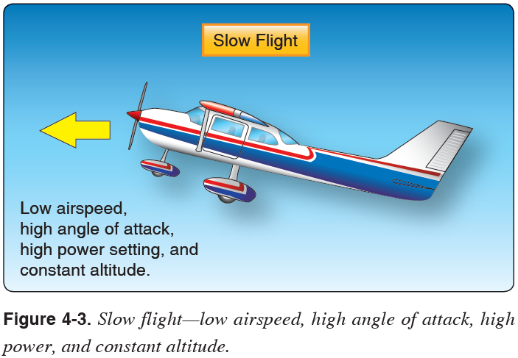

Common Errors:
- Failure to establish specified gear and flap configuration
- Improper entry technique
- Failure to establish and maintain the specified airspeed
- Excessive variations of altitude and heading when a constant altitude and heading are specified
- Uncoordinated use of flight controls
- Improper correction for torque effect
- Improper trim technique
- Unintentional stalls
- Inappropriate removal of hand from throttles
Power Off (approach) Stalls AFH 4-8 10-01-2019
Objective:
- Power-off stalls simulate a stall during the normal approach to landing in landing configuration
- Recoveries therefore train a pilot to make prompt, positive, and effective recoveries with a minimum loss of altitude
- This stall may occur while descending in an actual or simulated emergency or in any power-off situation when airspeed is not controlled

Procedure:
- Select an altitude (3000’ AGL) where recovery will occur no lower than 1500' AGL
- Perform clearing turns, call intensions 123.5
- Reduce power adjusting pitch to maintain altitude, trim as necessary
- Below V_{FE}, extend the flaps to 30º
- Maintain altitude until reaching a normal approach speed (65 kts) and then maintain that speed in a stabilized descent
- Simultaneously reduce power to idle and pitch up to Vy attitude (7º degrees pitch up)
- This pitch attitude will be a normal landing attitude
- At ~10 knots above stall speed the horn will sound
- Stall may be performed level or with up to 20° bank angles
- At the first indication of the stall (stall horn or buffet), call out "stalling"
- Reduce the AOA to regain control
- Add full power
- Pitch for Vy, 7º pitch up
- Maintain coordination using rudder to prevent spins
- With a positive rate of climb established, raise the flaps in 10° increments
- Complete cruise checklist, returning to the altitude, heading, and airspeed specified.

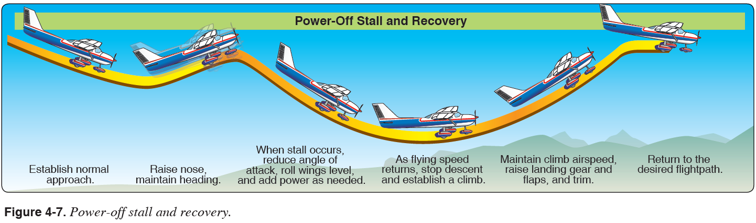

Common Errors:
- Failure to establish specified landing gear and flap configuration prior to entry
- Improper pitch, heading, yaw, and bank control during straight ahead stalls
- Improper pitch, yaw, and bank control during turning stalls
- Rough and/or uncoordinated use of flight controls
- Failure to recognize the first indications of a stall
- Failure to achieve a stall
- Improper torque correction
- Poor stall recognition and delayed recovery
- Excessive altitude loss or excessive airspeed during recovery
- Secondary stall during recovery
Power On (departure) Stalls AFH 4-9 10-01-2019
Objective:
- Helps recognize the indications of an imminent or full stall during power-on situations and to make prompt, positive, and effective recoveries with a minimum loss of altitude
- Power-on stalls simulate a stall from normal takeoff and departure

Procedure:
- Select an altitude (3000’ AGL) where recovery will occur no lower than 1500' AGL
- Perform clearing turns, call intensions 123.5
- Reduce power adjusting pitch to maintain altitude
- Trim as necessary
- Do not use flaps.
- At Vx = 62 kts, set full power and slowly increase pitch up to approx. 18° in straight flight or in turns with up to 20° bank
- Maintain heading control with rudder
- At the first indication of stall (horn or buffet), call out, "stall," and reduce the angle of attack to regain control effectiveness
- Add full power to regain airspeed and minimize altitude loss
- Pitch up to a Vx attitude and climb at 62 kts
- Maintain coordinated use of the ailerons and rudder to level the wings and prevent entering into a spin
- Adjust pitch to Vy attitude (74 kts) and minimize altitude loss, trim as necessary
- Level off in cruise configuration
- Complete cruise checklist, returning to the altitude, heading, and airspeed specified.

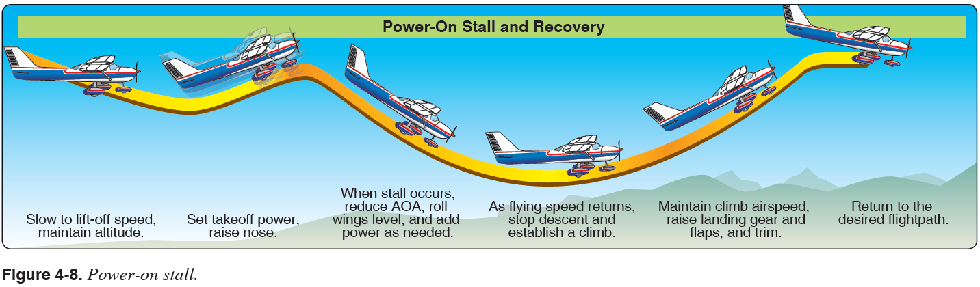
Common Errors:
- Failure to establish specified landing gear and flap configuration prior to entry
- Improper pitch, heading, yaw, and bank control during straight ahead stalls
- Improper pitch, yaw, and bank control during turning stalls
- Rough and/or uncoordinated use of flight controls
- Failure to recognize the first indications of a stall
- Failure to achieve a stall
- Improper torque correction
- Poor stall recognition and delayed recovery
- Excessive altitude loss or excessive airspeed during recovery
- Secondary stall during recovery
Cross-controlled Stall AFH 4-11
Objective:
- Cross-control stalls emphasize the importance of using coordinated control pressures whenever making turns
- Most apt to occur during a poorly planned and executed base-to-final approach turn
- Practicing approaches to stalls demonstrates the transition from cruise flight to critically slow airspeeds in various conditions

Procedure:
- Select an altitude (3000’ AGL) where recovery will occur no lower than 1500' AGL
- Commence a clearing turn, call intensions on 123.5
  - Reduce power adjusting pitch to maintain altitude, trim as necessary
  - DO NOT EXTEND THE FLAPS
- Maintain altitude until reaching a typical approach speed of 65 kts, establish a stabilize descent (trimmed) to simulate a normal approach to landing
- Descending no lower than 200' from the entry altitude, simultaneously reduce power to idle and pick a reference point off the left or right wing tip
- Turn towards the reference point using a 25-30° bank while:
  - Simultaneously applying excessive rudder pressure in the direction of turn (thereby accelerating the speed of outer wing in a skid)
  - Using opposite aileron to prevent over-banking (maintain a constant 25-30° bank) during the turn, and
  - Increasing elevator back-pressure to keep the nose from lowering
- At the imminent stall, callout, "stalling," reduce the angle of attack to regain control effectiveness, and apply full power
- Maintain coordinated use of the ailerons and rudder to level the wings and prevent entering into a spin
  - Adjust pitch to the V_{y} attitude and minimize altitude loss, re-trim as necessary
- Complete cruise checklist, returning to the altitude, heading, and airspeed required
  - Note that completion of the maneuver should occur by the 90° reference point and before full deflection of the rudder and aileron

Common Errors:
- Failure to adequately clear the area
- Failure to establish the selected config prior to entry (usually flaps up to avoid exceeding V_{FE} )
- Improper pitch, heading, and bank control during straight ahead stalls
- Improper pitch and bank control during turning stalls
- Rough or uncoordinated control technique
- Improper or inadequate demonstration of the recognition of and recovery from a crossed-control stall
- Improper or inadequate demonstration of the recognition of and recovery from a cross-controlled stall
- Failure to establish a cross-controlled turn and stall condition that would adequately demonstrate the hazards of a cross-controlled stall.
- Failure to present simulated student instruction that emphasizes the hazards of a cross-controlled condition in a gliding or reduced airspeed condition.
- Improper torque correction
- Excessive altitude loss or excessive airspeed during recovery
- Secondary stall during recovery.
Elevator Trim Stall AFH 4-12 10-01-2019
Objective:
- Elevator trim stalls demonstrate the effects of not maintaining positive airplane control during a go-around/rejected landing
- Elevator trim stalls show what can happen when full power is applied for a go-around and positive control of the airplane is not maintained
- Shows the importance of smooth power applications, overcoming strong trim forces, and maintaining positive control
Procedure:
- Select an altitude (3000’ AGL) where recovery will occur no lower than 1500' AGL
- Commence a clearing turn, call intensions 123.5.
- Reduce power, adjusting pitch (trimming) to maintain altitude
- Below 110 kts, flaps 10º, below 85 kts, flaps 30º – landing configuration
- Adjust pitch (trim) to maintain altitude
- Maintain altitude until reaching approach speed of 65 kts, and then establish a stabilized descent (trimmed) to simulate a normal approach to landing (3° down)
- Descending no lower than 200' from the entry altitude, apply full throttle:
  - allowing the airplane pitch to increase to the Vx pitch attitude
  - as the aircraft rolls left, use rudder to maintain heading (DO NOT USE AILERONS)
- Hold Vx pitch attitude until first indication of stall ( horn )
- Reduce the angle of attack to regain control effectiveness
- Pitch nose down to horizon and allow aircraft to accelerate to Vx
- Maintain coordinated use of the ailerons and rudder to level the wings
- Adjust pitch to the Vy attitude, raise the flaps in increments, to 10 °:
- Too abrupt of flap retraction will result in a dramatic loss of lift and possibly stall
- At or above Vy retract flaps to 0°
- As cruise airspeed is attained, set cruise power, re-trim as necessary
- Complete the Cruise Flow/Checklist

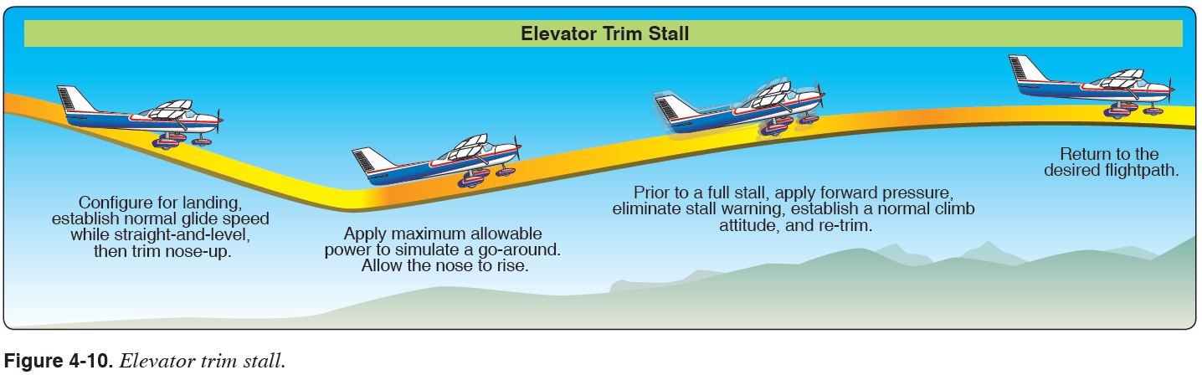

Common Errors:
- Failure to present simulated student instruction that adequately emphasizes the hazards of poor correction for torque and up-elevator trim during go-around and other maneuvers
- Failure to establish specified configuration prior to entry
- Improper or inadequate demonstration of the recognition of and recovery from an elevator trim stall
Secondary Stall AFH 4-10 10-01-2019
Objective:
- Secondary stalls are caused by attempting to hasten the completion of a stall recovery before the airplane has regained sufficient flying speed
- It also occurs when the pilot fails to reduce the angle of attack sufficiently during stall recovery by not lowering pitch attitude sufficiently, or by attempting to break the stall by using power only
- When this stall occurs, the back-elevator pressure should again be released just as in a normal stall recovery.

Procedure:
- Select an altitude (3000’ AGL) where recovery will occur no lower than 1500' AGL
- Perform clearing turns. call intensions 123.5.
- Perform a power-off stall &/or power-on stall as directed
- At the stall, call out, "stalling," and reduce the angle of attack to regain control effectiveness
- Add full power to regain airspeed
- Maintain coordinated use of the ailerons and rudder to level the wings and prevent entering into a spin
- Immediately increase the pitch attitude to induce another (secondary) stall
- At the stall, callout, "stalling," reduce the angle of attack to regain control effectiveness
- Add full power to regain airspeed
- Maintain coordinated use of the ailerons and rudder to level the wings and prevent entering into a spin
- Adjust pitch to the Vx attitude, re-trimming as necessary and minimizing altitude loss
- With a positive rate of climb established:
- As airspeed increases, raise the flaps in increments, to 10 °:
  - Too abrupt of flap retraction will result in a dramatic loss of lift and possibly stall
- At or above Vx retract flaps to 0°
- Complete cruise checklist, returning to the altitude, heading, and airspeed specified

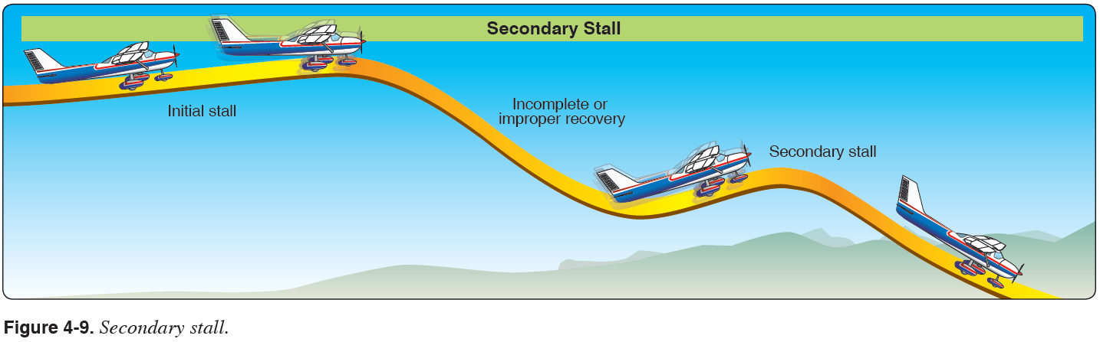
Common Errors
- Failure to establish specified configuration prior to entry
- Improper or inadequate demonstration of the recognition of and recovery from a secondary stall
- Failure to present simulated student instruction that adequately emphasizes the hazards of poor procedure in recovering from a primary stall.

Accelerated Maneuver Stall AFH 4-10 10-01-2019

Objective: To demonstrate to the student that a stall is a function of angle of attack & load factor, rather than airspeed.
A stall encountered anytime the G-load exceeds +1G is called an Accelerated Stall.

Procedure:
- Perform this maneuver so that the recovery takes place at or above 3000’ AGL. (3300’ MSL)
- Clearing Turns (left then right), Call intensions 123.5
- Reduce power to 1500 RPM and reduce airspeed.
- DO NOT EXTEND FLAPS
- At 68 KIAS (20 KIAS above Vs):
- Adjust pitch to maintain altitude.
- Establish 45° of bank.
- Smoothly increase back pressure until the impending stall is reached.
- At the first indication of impending stall ( horn &/or buffet):
- Verbally announce the onset of the stall.
- Lower the pitch attitude slightly below a level pitch attitude.
- Use coordinated control inputs to maintain directional control and level the wings.
- Add full power.
- Adjust the pitch to an attitude that allows a positive rate of climb and an increase in airspeed to V_{y}.
- Upon reaching the specified recovery altitude, trim the aircraft for cruise.
Note: Never perform this maneuver with flaps extended.

The increased back pressure increased AOA, which increases the lift and thus the G load.

The increased G load increases the stall speed. The increase lift will also increase drag resulting in a decrease of airspeed.

For 172 S, stall speed 0º angle of bank, clean = 48 kts / stall speed 45º angle of bank, clean = 57 kts

Common Errors
- Failure to establish proper configuration prior to entry
- Improper or inadequate demonstration of the recognition of and recovery from an accelerated maneuver stall
- Failure to present simulated student instruction that adequately emphasizes the hazards of poor procedures in recovering from an accelerated stall

Steep Turns AFH 9-2 10-01-2019
- Develops smoothness, coordination (ball centered), orientation, & aircraft control in steep banked turn.
- Uses a bank angle steep enough to cause an overbanking tendency.
A/C max G load = 3.8 G’s, 60º bank LF = 2 G’s, 70º bank LF = 2.8 G’s, 78º bank LF = 3.8 G’s
Stall Speed: at 60º bank stall speed increases by 40%, from 48 kts to 67 kts

Steep turns will expose the pilot to:
- higher load factors
- airplanes inherent overbanking tendency past 30º of bank
- loss of vertical component of lift when the wings are steeply banked
- need for substantial pitch control pressures
- need for additional power to maintain altitude and airspeed

- 2,000’ MSL (min 1500’ AGL), DOWNWIND
- Clearing Turns (left then right). Call intensions 123.5
- Confirm Airspeed, Altitude, reference heading
- Power 2250 rpm, 95 kts (as specified in the POH, below Va)
Keep your eyes outside for situational awareness - Use section lines and prominent landmarks
- Establish attitude for steep turn, 50º bank.
- Thru 30º of bank:
- Increase pitch ( 2º nose up ) due to decrease vertical lift vector
- Add 100 rpm ( + ¼” throttle ) to overcome induced drag and maintain airspeed
- Monitor outside reference on dash for bank and attitude corrections
(Trim 2 to 2 ½ turns of trim wheel if desired)
- Add power as required to overcome induced drag and maintain airspeed
- Watch for reference heading and lead rollout by 20º (1/2 of the bank angle)
- Repeat 360º turn in other direction
Completion:
(Altitude +/- 100’, Airspeed +/- 10 kts, Bank +/- 5º, roll out on entry heading +/- 10º
Discussion: Load factor, Angle of bank limitations, effect on stall speed, power required, overbanking tendency

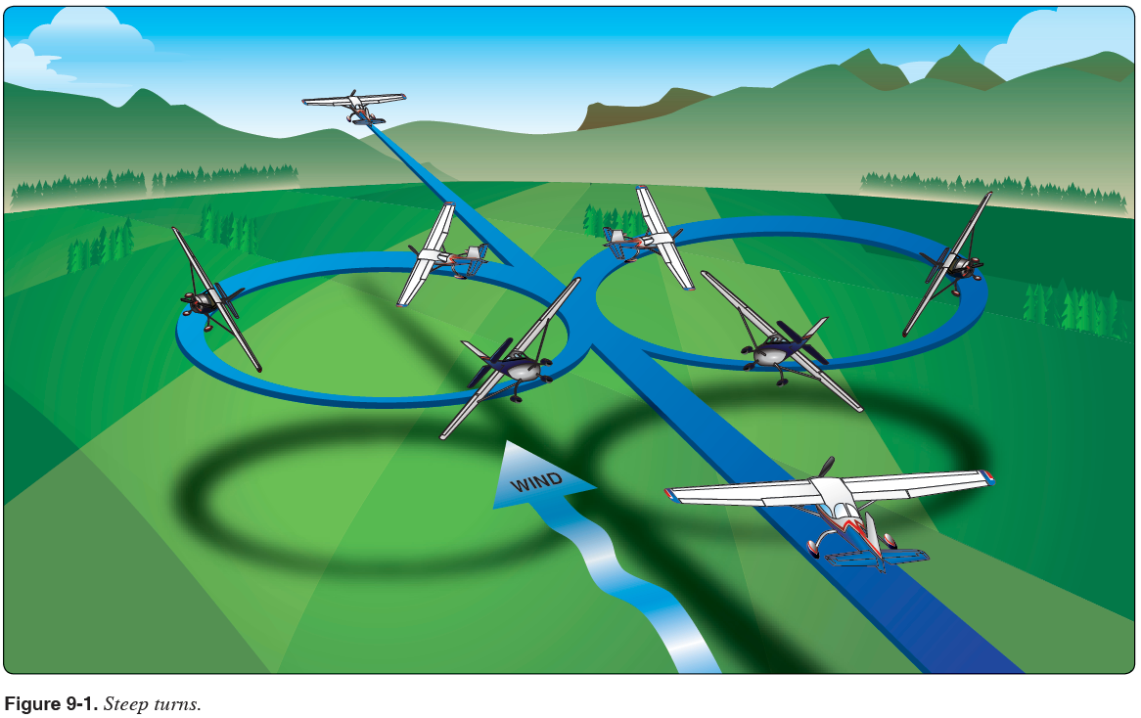

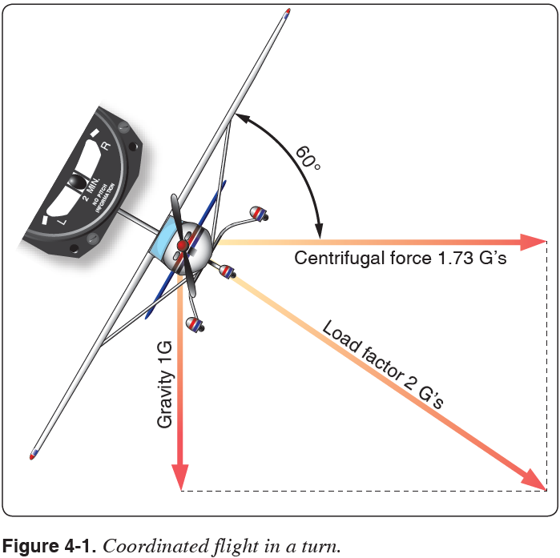

Common Errors
- Not clearing the area
- Improper pitch, bank, &/or power coordination during entry &/or rollout
- Gaining altitude or losing altitude
- Improper technique in correcting altitude deviations
- Failure to maintain constant bank angle
- Uncoordinated use of flight controls
- Ineffective use of trim
- Ineffective use of power
- Inadequate airspeed control
- Loss of orientation
- Performing by reference to the flight instruments rather than visual references
- Failure to scan for other traffic during the maneuver
- Attempts to start recovery prematurely
- Failure to stop the turn on designated heading

Steep Spiral AF 9-4 10-01-2019

Objective: Develops skill with Power-off turns, wind drift control, planning, coordination, orientation, & division of attention.
Procedure:
- Clear the area
- Start at 4000’ to allow 3 complete turns before 1,500’ AGL
- Establish best glide speed of 68 kts
- Pick a suitable ground reference point
- Establish Steep Spiral downwind with a 45º -55º bank at 68 kts. (steepest bank < 60º) to maintain a constant radius about a suitable ground reference point.
- Clear engine each time you turn into the wind.
- Use steep and shallow banks as drift requires to track a constant radius circle around the selected reference point.
- Stay coordinated, vary back pressure with bank angle as required to maintain airspeed

Completion:
( Airspeed +/- 10 kts, roll out on entry heading +/- 10º, complete maneuver no lower than 1,500’ AGL )

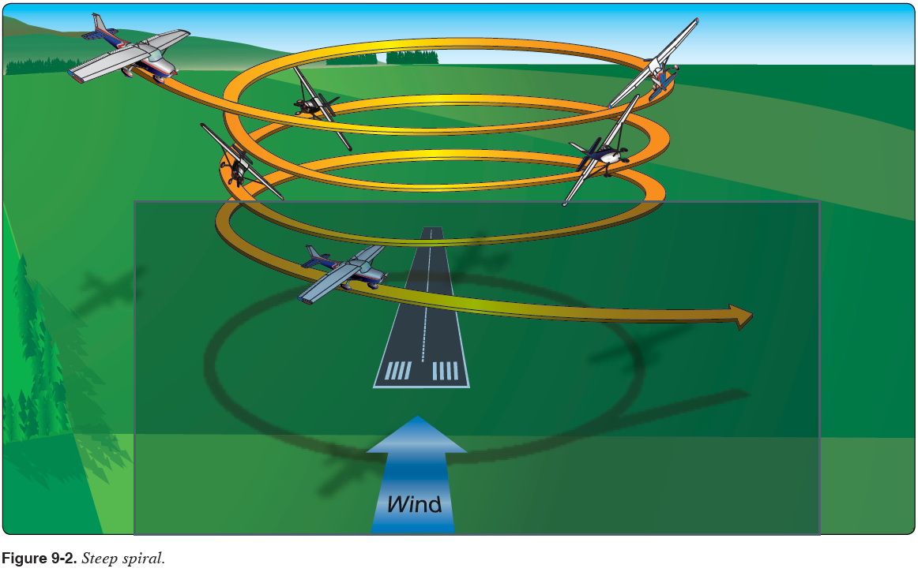
NOTE: (if performing Steep Spiral followed by emergency approach to landing)
When spiraling, the bank angle can be adjusted to vary altitude loss so as to arrive at the high key point at the appropriate altitude. The Cessna 172S loses approx. 800 -1000' in a 20° bank - 360° turn; and approximately 400 - 500' in a 45° bank - 360° turn. If altitude does not permit the use of a high-key point, proceed to a low key point

Steep Spiral (con’t) AF 9-4

Common Errors
- Not clearing the area
- Improper pitch, bank, yaw, &/or power coordination during entry or completion
- Not correcting the bank angle to compensate for the wind
- Uncoordinated use of flight controls
- Improper planning and lack of maintenance of constant airspeed and radius.
- Ineffective use of trim
- Inadequate airspeed control
- Failure to stay orientated to the number of turns and the rollout heading.
- Performing by reference to the flight instruments rather than visual references
- Not scanning for other traffic during the maneuver
- Not completing the turn on designated heading or reference
Chandelle AFH 9-5 10-01-2019
A maximum performance climbing 180º turn developing the pilot’s orientation and flying skills (coordinated flight) at varying airspeeds and attitudes.

2,000’ AGL (min 1500’ AGL)
Clearing Turns (left then right), Call intensions 123.5
Confirm Va Airspeed, Altitude, and outside references
Power 2350 rpm, 105 kts, clean configuration
Keep your eyes outside for situational awareness
- Use section lines and prominent landmarks for orientation

Establish 30º bank, increase pitch, full power (Bank, Pitch, Power)

0 - 90º ..... constant 30º of bank, increasing pitch to max pitch attitude (~17º up), A/S slowing
(5º of pitch up per 30º of turn) Increasing need for right rudder as a/c slows

90º - 180º ….. constant pitch attitude, decreasing bank, wings level at 180º, slowest AS (50-55 kts)
Continued need for additional right rudder, increasing pitch pressure

Complete rollout at the 180o point, +/- just above stall speed, maintaining that airspeed momentarily while avoiding a stall.

Recovery:
- to level cruise flight with minimum loss of altitude
- perform cruise checklist

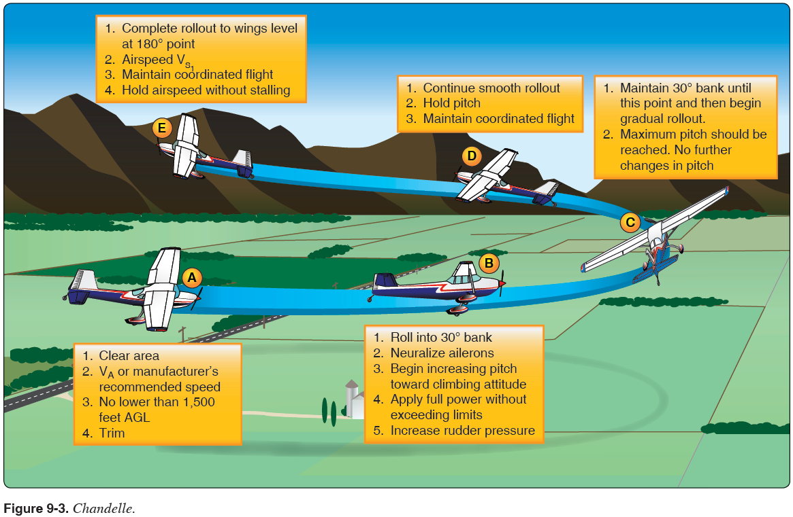

Chandelle (con’t) AFH 9-5

Common Errors
- Not clearing the area
- Initial bank is too shallow resulting in a stall
- Initial bank is too steep resulting in failure to gain maximum performance
- Allowing the bank angle to increase after initial establishment
- Not starting the recovery at the 90º point in the turn
- Allowing the pitch attitude to increase as the bank is rolled out during the second 90º of turn
- Leveling the wings prior to the 180º point being reached
- Pitch attitude is low on recovery resulting in airspeed well above stall speed
- Application of flight control pressures is not smooth
- Improper pitch, bank, yaw, &/or power coordination during entry or completion
- Uncoordinated use of flight controls
- Improper planning and timing of pitch and bank attitude changes
- Factors relating to failure in achieving maximum performance
- A stall during the maneuver
- Execution of a steep turn instead of a climbing maneuver
- Not scanning for other traffic during the maneuver
- Performing by reference to the flight instruments rather than visual references

Lazy 8’s AFH 9-6 10-01-2019

A combination of alternating (R&L) climbing & descending 180º turns developing the pilot’s orientation and flying skills (coordinated flight) across a wide range of airspeeds and attitudes

3,000’ (ACS = min 1500’ AGL), perpendicular to the wind (turns into the wind)
Clearing Turns (left then right), Call intensions 123.5
Confirm Va airspeed, altitude, and outside 45°, 90°, and 135° reference points
Power 2350 rpm, 105 kts
Keep your eyes outside for situational awareness - Use section lines and prominent landmarks for orientation
Begin pitch and lazy bank simultaneously

0 - 45º ..... 15º of bank, highest pitch attitude (~17º up), slowing airspeed
( start with very slow roll and increase pitch, more right rudder as a/c slows )
45º - 90º ….. 30º of bank, pitch attitude dropping thru horizon, slowest airspeed (53-58 kts)
(Cross control may be required to not exceed 30º of bank)
90º - 135º ..... 15º of bank, lowest pitch attitude (~12º dwn), increasing airspeed
( decrease right rudder as a/c speed increases )
135º - 180º ….. 0º of bank, level pitch attitude, entry airspeed, entry altitude, entry heading

(Turn to right will require more rudder due to additive left turning tendency + adverse yaw)

Verbalize airspeed, altitude, and outside reference heading
(Altitude +/- 100’, Airspeed +/- 10 kts, roll out on entry heading +/- 10º

Immediately begin turn in opposite direction, repeat same steps in this new direction

Symmetry Checks Input Changes
Points 0º & 180º - airspeeds & altitudes are equal - Pitch, roll & yaw inputs continuously vary throughout the Lazy 8
45ºL & 45ºR - altitudes are equal - Orientation & coordination are paramount skills to develop
90ºL & 90ºR - altitudes are equal - Coordinated flight is primary goal
135ºL & 135ºR - altitudes are equal

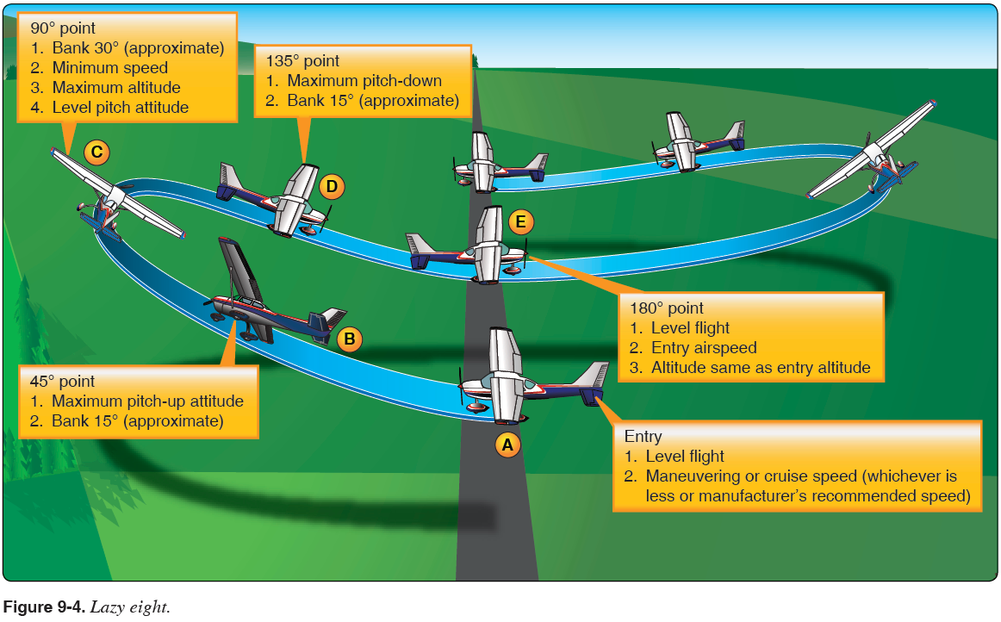

Lazy Eights Procedure:

- Perform clearing turns
- Adjust the pitch and power to maintain altitude and set V_{a} power
  - Trim as necessary
- Pick 45°, 90°, and 135° reference points on or out to the horizon
  - The farther away, the more accurate and steady they will be.
- From straight and level flight, initiate a climbing turn (simultaneously increase bank and pitch slowly) in the direction of the 45° reference point
  - Slowly increase bank and pitch so that at the 45° point the airplane is passing through 15° of bank and maximum pitch up (~ 15°)
  - If bank is too fast, the aircraft will increase the rate of turn too quickly and reach 45° point before highest pitch is attained
- At the 45° reference point the max pitch up should be achieved with a 15° bank angle slowly continuing to increase to 30°
- From the 45° reference point, while allowing the bank angle to continue increasing, allow the pitch to decrease so that at the 90° reference point the maximum bank angle (30°) is achieved and the pitch attitude is passing through level flight at minimum airspeed (5-10 knots above V_{S} ) (Max Altitude)
  - Right rudder pressure will have to be applied to counteract torque
  - More right rudder is required during the climbing turn to the right than in the turn to the left
  - Note altitude gain at the 90° point
- From the 90° reference point, allow the pitch attitude to continue decreasing and initiate a slow decrease in the bank angle, continuing a descending turn in the direction of the 135° reference point
  - Continue to decrease pitch and slowly decrease bank so that at the 135° point, the airplane is passing through 15° of bank and maximum pitch down (~10° nose down)
- At the 135° reference point, the maximum pitch down (lowest) attitude should be achieved with a 15° bank angle continuing to slowly decrease to 0°
- From the 135° reference point, continue decreasing the bank angle while allowing the pitch to increase so that the airplane returns to the entry airspeed and altitude by the 180° reference point
  - The airspeed should not exceed the entry airspeed during the turn from the 90° reference point to the 180° reference point
- From the 180° point, immediately commence a climbing turn in the opposite direction, repeating the steps above
  - Upon completion of the maneuver, resume normal cruise, re-trim as necessary
- Complete cruise flow/checklist

Common Errors:
- Not clearing the area
- Inadequate pitch control on entry or rollout
- Gaining or losing altitude
- Failure to maintain constant bank angle
- Poor selection of reference points
- Uncoordinated use of flight controls
- Unsymmetrical loops resulting from poorly planned pitch and bank attitude changes
- Inconsistent airspeed and altitude at key points
- Loss of orientation
- Excessive deviation from reference points
- Allowing the pitch attitude in the last 90º of turn to become excessively low resulting in exceeding the initial entry airspeed and or altitude.
- Ineffective use of trim / power
- Inadequate airspeed control
- Performing by reference to the flight instruments rather than visual references
- Failure to scan for other traffic during the maneuver
- Failure to stop the turn on designated heading.
Eight’s on Pylons AFH 6-14
- The most advanced and difficult of the ground reference maneuvers.
Objective: To teach the student to maneuver an aircraft at a pivotal altitude
around ground reference points while maintaining division of attention,
coordination, and smooth control inputs.
Procedure:
- 900’ AGL, ~1,200 MSL
- Clear for traffic, Call intensions 123.5
- Confirm Va airspeed, altitude, and outside references
- Power 2300 rpm, 100 kts
Keep your eyes outside for situational awareness - Use section lines and prominent landmarks for orientation
- Perform this maneuver at or below maneuvering speed.
- Determine the wind direction.
- Select two reference points perpendicular to the wind direction from which an emergency landing can be made should the need arise.
- Determine the pivotal altitude by squaring the ground speed and dividing the result by 11.3.
8. Enter the maneuver 45° to the downwind with first turn into wind.
9. Once abeam the pylon, begin the turn.
a. The steepest bank angle should not exceed 40°.
- Vary altitude to maintain the reference line on the pylon.
a. Pylon moves forward - pitch down and reduce bank angle.
b. Pylon moves rearward - pitch up and increase bank angle.
- Plan rollout from 1st pylon to allow for a 45° entry & 3-5 seconds of level flight to the next pylon
12. Once abeam the second pylon, begin to turn in the opposite direction.
13. After completing the turn around the second pylon, depart the maneuver on the entry heading.
14. After the maneuver is complete, trim the aircraft for cruise.

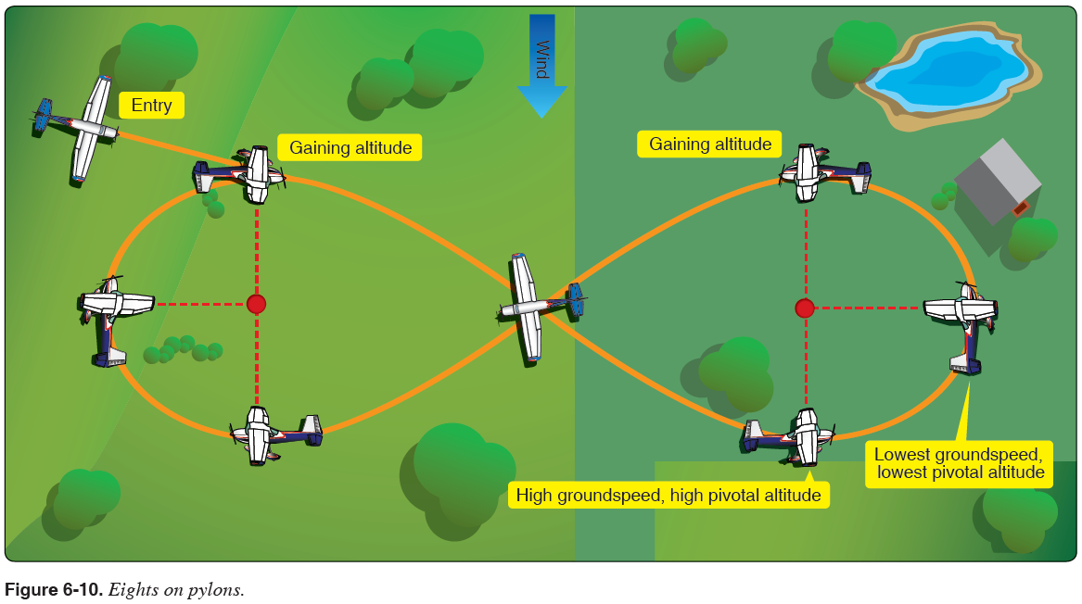
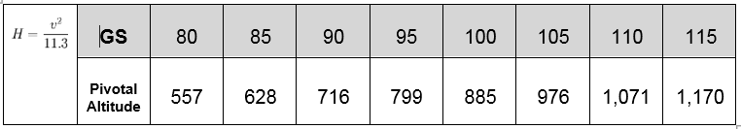

Common Errors
- Attempting to hold a pylon with incorrect use of rudder
- Failure to adequately clear the area above, below, and on either side of the airplane for safety hazards, initially and throughout the maneuver.
- Poor selection of ground references.
- Failure to establish a constant, level altitude prior to entering the maneuver.
- Failure to maintain adequate altitude control during the maneuver.
- Failure to properly asses wind direction.
- Failure to properly execute constant radius turns.
- Failure to manipulate the flight controls in a smooth and continuous manner.
- Failure to establish the appropriate wind correction angles.
- Failure to apply coordinated aileron and rudder pressure, resulting in slips or skids.
- Failure to maintain orientation as the maneuver progresses.

From CFI-A PTS
- Faulty entry procedure
- Poor planning, orientation, and/or division of attention
- Uncoordinated use of flight controls
- Use of an improper "line-of-sight" reference
- Application of rudder alone to maintain "line-of-sight" on
- Improper timing for turn entries and rollouts
- Improper correction for wind drift between pylons
- Selection of pylons where there is no suitable emergency landing area within gliding distance

Rectangular Course AFH 6-6
- ground reference maneuver designed to replicate flying in the airport traffic pattern

Procedure:

- 1,000’ AGL, ~1,200 MSL
- Clear for traffic, Call intensions 123.5
- Confirm Va airspeed or below, altitude, and outside references
- Power 2250 rpm, 95 kts
Keep your eyes outside for situational awareness - Use section lines and landmarks for orientation
- Determine the wind direction
- Select a rectangular area from which an emergency landing can be made should the need arise.
- Plan to enter the maneuver for either a left or right pattern.
- Enter the maneuver at 800-1000’ AGL.
- Enter the downwind on a 45° angle.
- Throughout the maneuver, establish a crab angle to maintain a uniform distance around the rectangular reference area at approximately ½ - ¾ mile.
- Vary the bank angle as appropriate based upon groundspeed to maintain a constant radius during the turns.
- At least one lap of the rectangle is required though more may be completed for practice purposes.
- After the maneuver is complete, trim the aircraft for cruise.

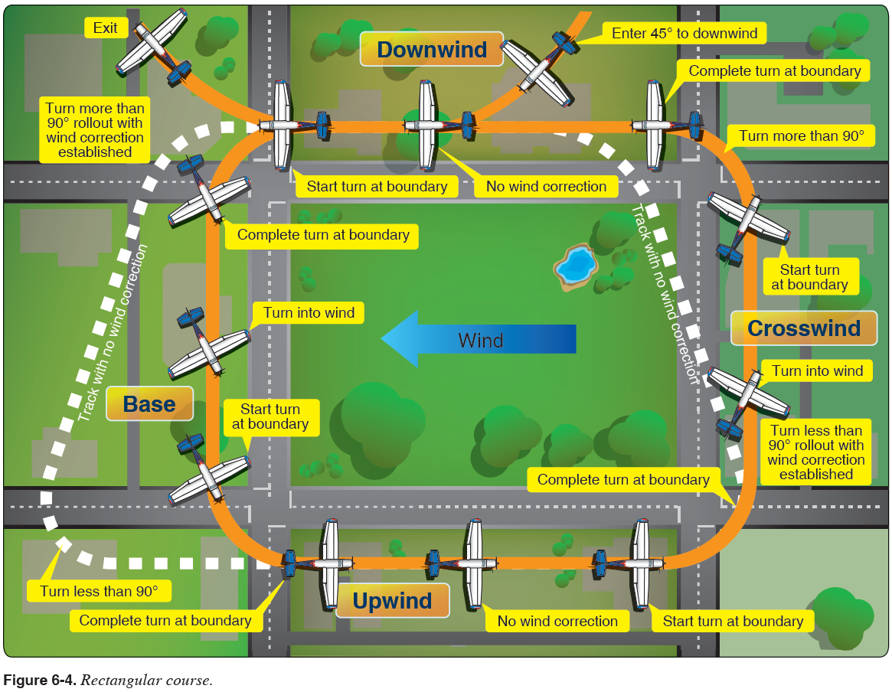

Common Errors
- Poor planning, orientation, or division of attention
- Uncoordinated use of flight controls
- Improper correction for wind drift
- Failure to maintain selected altitude or airspeed
- Selection of a ground reference where there is no suitable emergency landing area within gliding distance

S Turns Across a Road AFH 6-10
- ground reference maneuver in which the airplane’s ground track resembles two opposite but equal half circles on each side of a selected ground based straight line reference.

Procedure:
- 1,000’ AGL, ~1,200 MSL
- Clear for traffic, Call intensions 123.5
- Confirm Va airspeed or below, altitude, and outside references
- Power 2250 rpm, 95 kts
Keep your eyes outside for situational awareness - Use section lines and landmarks for orientation
- Determine the wind direction
- Select a reference line that is perpendicular to the wind from which an emergency landing can be made should the need arise.
- Enter the maneuver at 800-1000’ AGL.
- Enter the maneuver on the downwind.
- Begin the turn back towards the reference line once the wind is abeam the reference line.
- Vary the bank angle as appropriate based upon groundspeed to maintain a constant radius during the turns.
  - Adjust the pitch attitude to maintain altitude.
  - The steepest bank angle should not exceed 45º.
- The wings should be level and in transit to the opposite direction turn as the aircraft crosses the reference line.
- Repeat steps 9-10 to complete the second half circle.
- After the maneuver is complete, trim the aircraft for cruise.

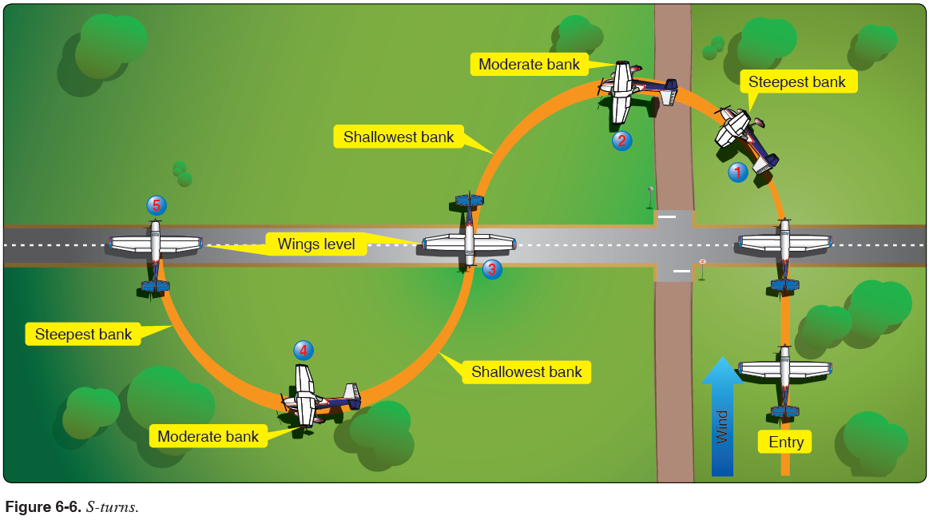

Common Errrors
- Faulty entry procedures
- Poor planning, orientation, or division of attention
- Uncoordinated use of flight controls
- Improper correction for wind drift
- An unsymmetrical ground track
- Failure to maintain selected altitude or airspeed
- Selection of a ground reference line where there is no suitable emergency landing area within gliding distance
Turns Around a Point AFH 6-8
- ground reference maneuver which is a 360o constant radius turn around a single ground reference point.

Procedure:
- 1,000’ AGL, ~1,200 MSL
- Clear for traffic, Call intensions 123.5
- Confirm Va airspeed or below, altitude, and outside references
- Power 2250 rpm, 95 kts
  - Keep your eyes outside for situational awareness - Use section lines and landmarks for orientation
- Determine the wind direction
- Select a reference point from which an emergency landing can be made should the need arise.
- Enter the maneuver at 800-1000’ AGL.
- Enter the maneuver on the downwind.
- Begin the turn once the wing is abeam the point.
- Vary the bank angle as appropriate based upon groundspeed to maintain a constant radius during the turns.
  - Adjust the pitch attitude to maintain altitude.
  - The steepest bank angle should not exceed 45º.
- At least one lap of the maneuver is required though more may be completed for practice purposes.
- After the maneuver is complete, trim the aircraft for cruise.

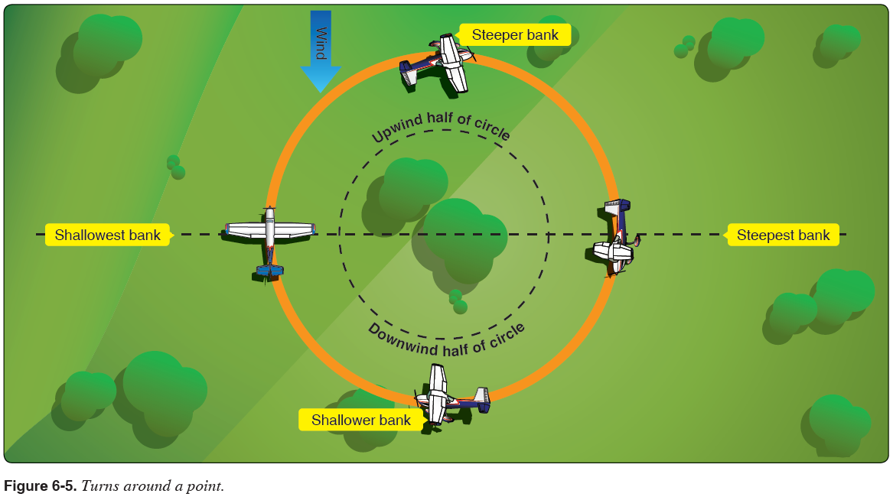

Common Errors
- Faulty entry procedure
- Poor planning, orientation, or division of attention
- Uncoordinated use of flight controls
- Improper correction for wind drift
- Failure to maintain selected altitude or airspeed
- Selection of a ground reference point where there is no suitable emergency landing area within gliding distance

Engine Fire Emergency Descent AFH 17-7
Objective: To develop the student’s ability to descend the airplane as rapidly as possible, within the limitation of the airplane.
Procedure:
- Brief passengers on the maneuver.
- Complete landing checklist.
- Simulate the Engine Fire checklist
- Reduce power to idle.
- Lower the pitch of the aircraft while rolling into a 45° bank.
- Adjust the pitch of the aircraft to maintain 100 KIAS.
- Roll out of the maneuver after 90° of heading change by first rolling wings level and then
pitching up.
- Use a 30° S-turn to clear the area.
- Smoothly advance the throttle to 2300 RPM.
- After the maneuver is complete, trim the aircraft for cruise.
Note: Enriching of the mixture may be required at the end of the maneuver before advancing the throttle.
Note: This maneuver is permitted only on dual flights.
Note: Recover no lower than 500’ AGL.
Caution: Do NOT exceed Vno unless in smooth air. Use V_{a} when necessary.

Spins AFH 4-14
Objective: To develop the student’s ability to recognize, recover from, and enter spins.
Procedure:
- Perform this maneuver so that recovery takes place at or above 4,000 AGL.
- Complete CRAGS.
- Reduce power to idle while raising the nose of the aircraft to an attitude which will induce a
stall.
- At the buffet:
- Apply full rudder in the direction of the desired rotation.
- Apply full up elevator.
- Ensure that the throttle is at idle.
- At the completion of three full rotations:
    - Ensure that the throttle is at idle.
(P – power to idle)
    - Neutralize the ailerons.
(A – ailerons to neutral)
    - Apply and HOLD full rudder opposite of the direction of rotation.
(R – full opposite rudder to stop the spin)
    - Move the control wheel briskly forward just enough to break the stall.
(E – elevator briskly forward to break the stall)
    - Hold these control inputs until the rotation stops.
    - As the rotations stops, neutralize the rudder and make a smooth recovery from
the resulting dive.
- After the completion of the maneuver, increase power to 2300 RPM and trim the aircraft for
cruise.

Note: This maneuver is only authorized in the CFI course.
Note: Weight and balance computations must be performed to assure the aircraft is in the utility category.

